Starting Distribution: “ $x$”

with Mean $μ$ and St. Dev $σ$

**Why Do We Need $t$?**

Work to get to the end, and YOU will be able to EXPLAIN it.

Consider means from all possible samples of size $n$.

If conditions are satisfied, then the CLT says…

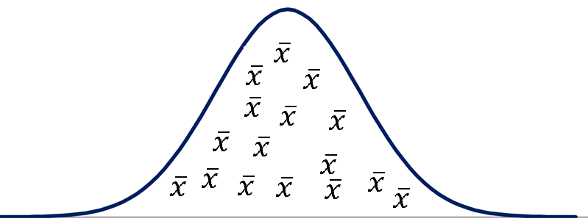

Approximately **Normal**!

Don’t need $t$ when discussing sampling distribution of . ☺

You already did this in Ch 18!

$↖$ This normality is something you must establish in the 1-Samp $t$-test conditions.

But when we try to ***standardize*** these means…

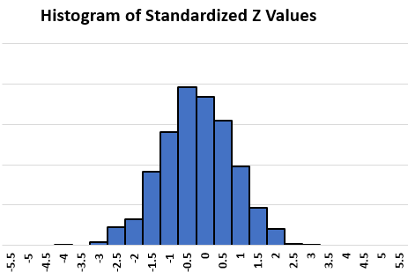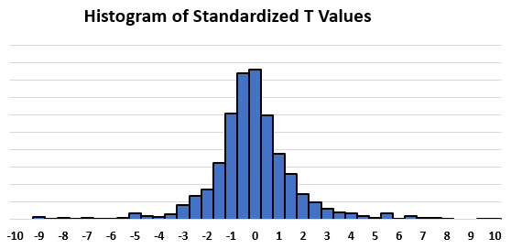

Don’t know $σ$?

$$t=\frac{\overline{x}-μ}{s/{\sqrt{n}}}$$

Know $σ$?

$$z=\frac{\overline{x}-μ}{σ/{\sqrt{n}}}$$

Summary:   
Don’t know $σ$ when standardizing? Use $s$ from the sample. (It’s the best you’ve got.)   
But $\frac{\overline{x}-μ}{s/{\sqrt{n}}}$ just won’t be distributed the same way as $\frac{\overline{x}-μ}{σ/{\sqrt{n}}}$. And that is why we use…

* different distributions.
* a different variable name.
* a different button on our calculator. (“tcdf”)

Advanced Pondering:   
Why doesn’t $\hat{p}$ have this problem?  
Come tell me if you figure it out! ☺

But in some samples…

… $s$ could be ludicrously small   
...so $\frac{\overline{x}-μ}{s/{\sqrt{n}}}$ could be ludicrously big